wORKING WITH EC2 INSTANCES

**AWS EC2**

Contents

LAUNCH OR SPINNING AN EC2 INSTANCE 2

Name 2

Instance Type and Key pair 3

Creating Security Group 3

Providing User Data 4

Test 6

Connecting Instance using EC2 instance connect 7

CREATING IMAGE AND SNAPSHOT 8

CREATE LAUNCH TEMPLATE 9

Name and description 9

Attach AMI 10

Instance type and key pair 10

Attach Security group 11

Add User data 11

CREATE AUTO SCALING GROUP 12

Attach Template 13

Define Network –VPC, Availability Zones and subnet 13

Configure group size and scaling policies 15

Check Activity 17

CREATING TARGET GROUP 19

Name and protocol 19

Register targets and include as pending below 20

CREATE LOAD BALANCER 22

Types of Load balancer 22

Type selection 22

Network Mapping – Select subnets 23

Attach Target group to Listener 24

DNS generation and Test 25

Enabling Cross-Zone load balancing 26

Attach Target group to Auto Scaling group 27

LIFECYCLE HOOK 29

WARM POOLS 33

# LAUNCH OR SPINNING AN EC2 INSTANCE

## Name

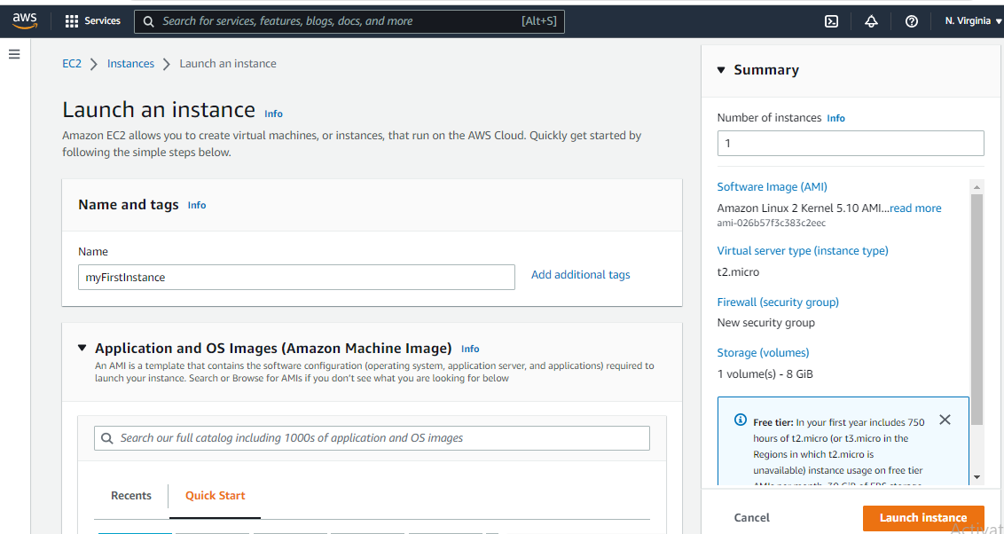

AMI

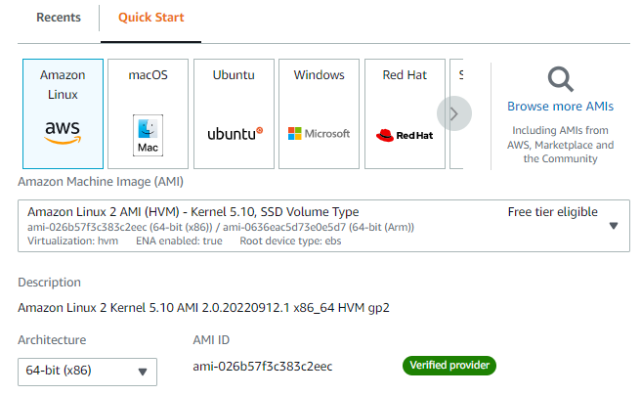

## Instance Type and Key pair

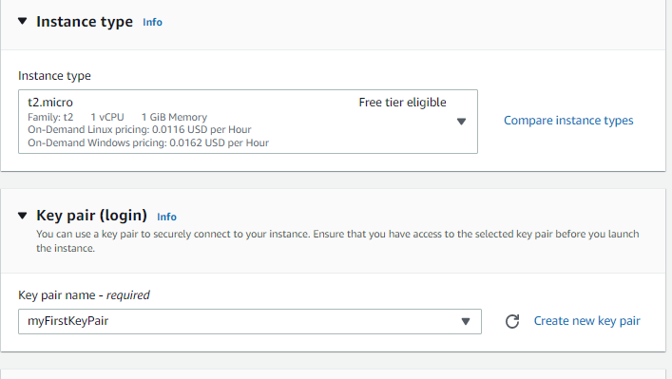

## Creating Security Group

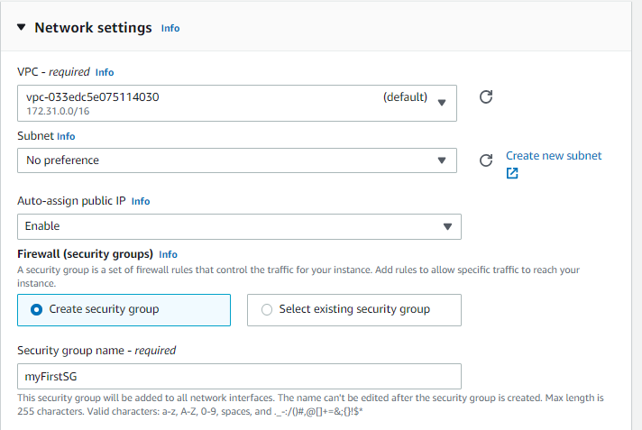

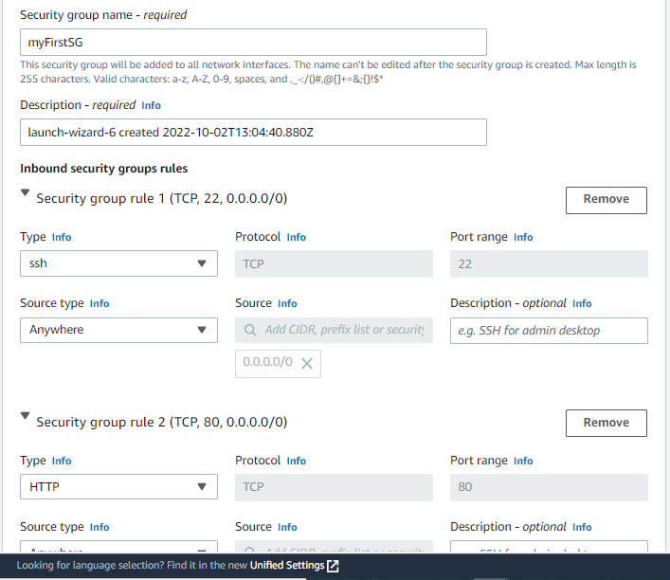

## Providing User Data



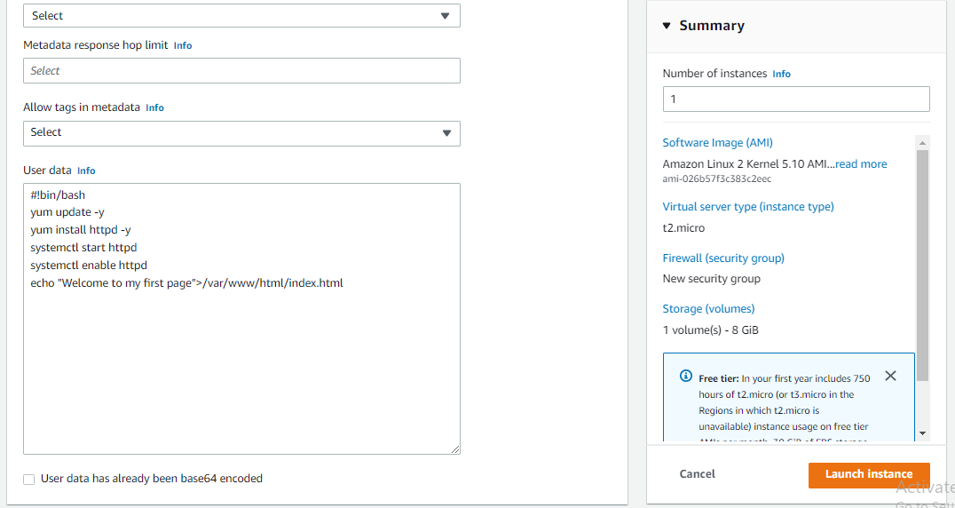

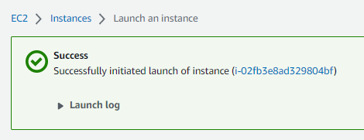

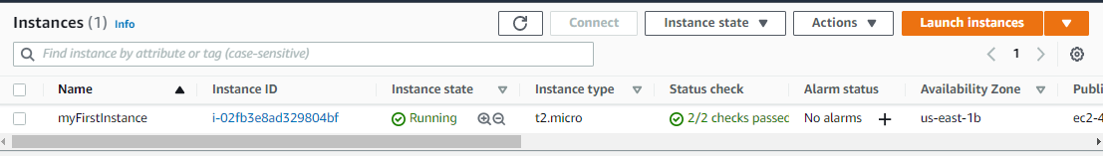

## Test

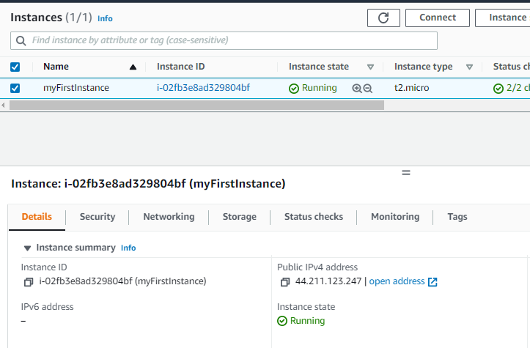

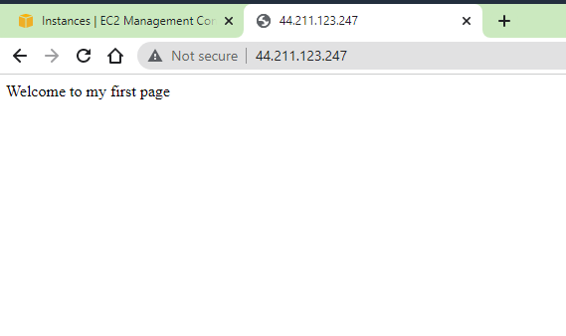

## Connecting Instance using EC2 instance connect

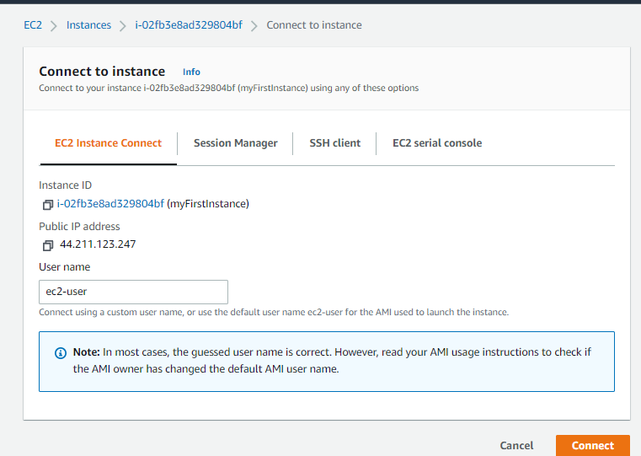

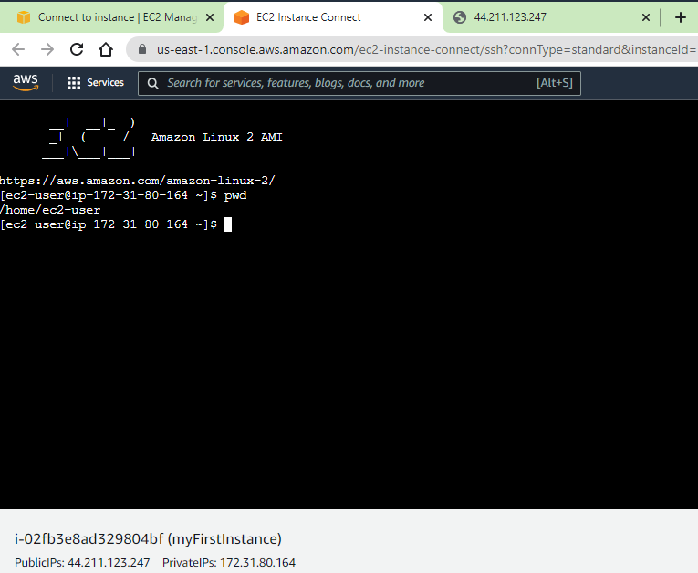

# CREATING IMAGE AND SNAPSHOT

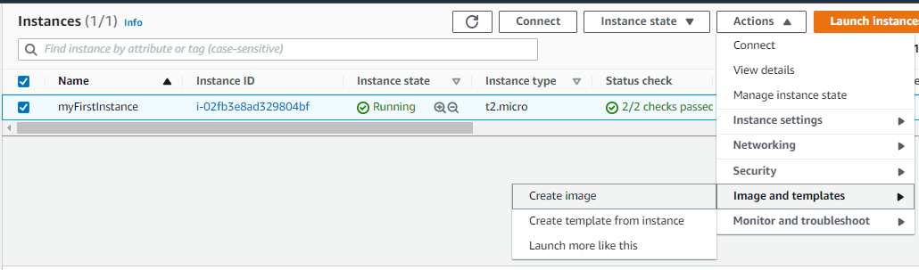

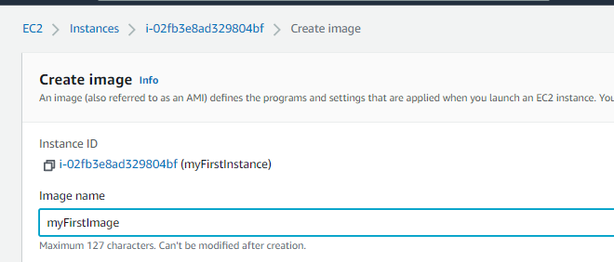

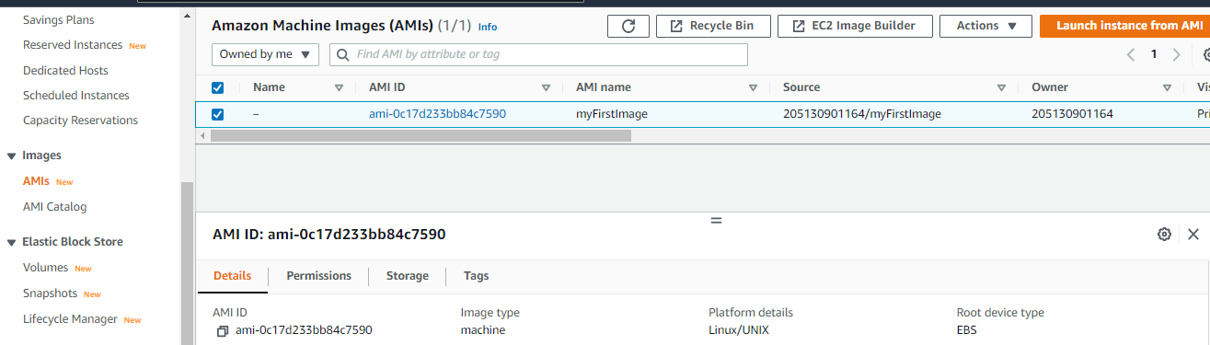

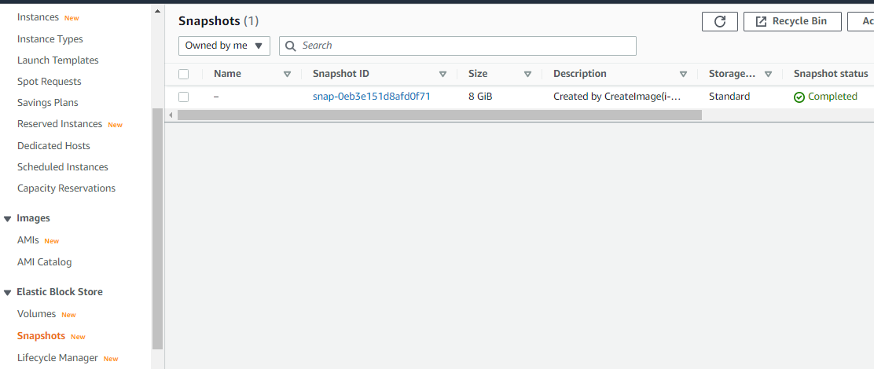

# CREATE LAUNCH TEMPLATE

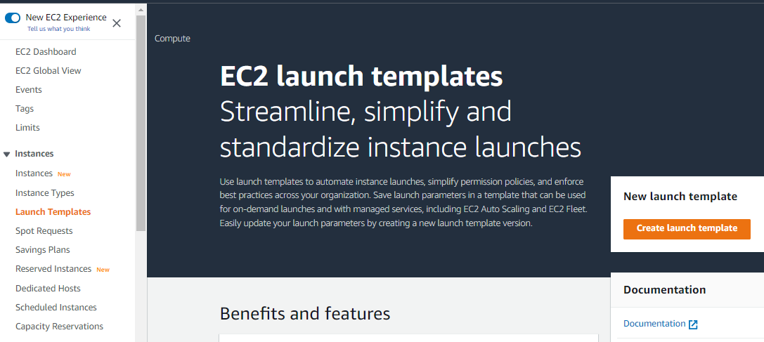

## Name and description

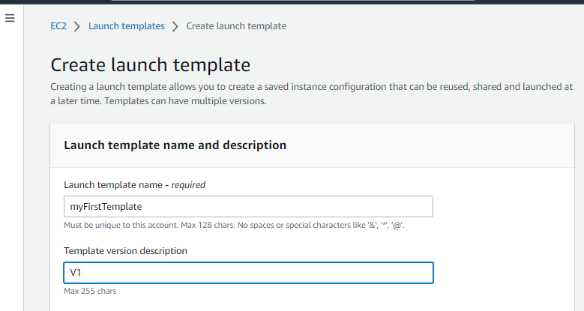

## Attach AMI

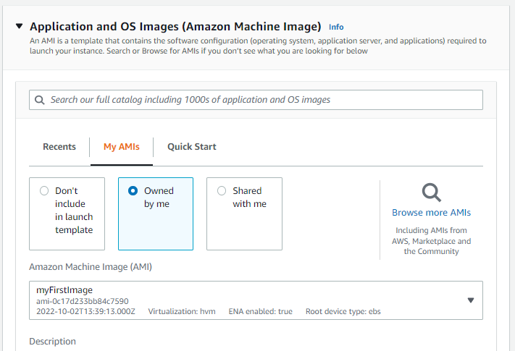

## Instance type and key pair

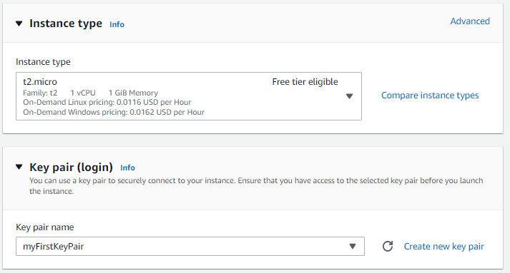

## Attach Security group

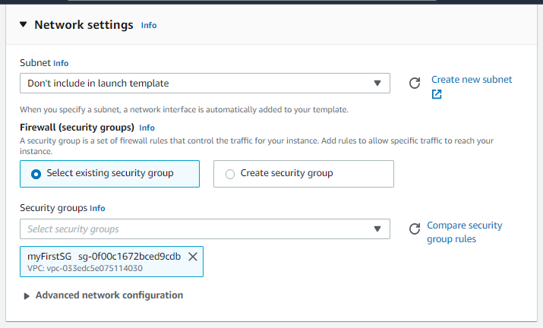

## Add User data

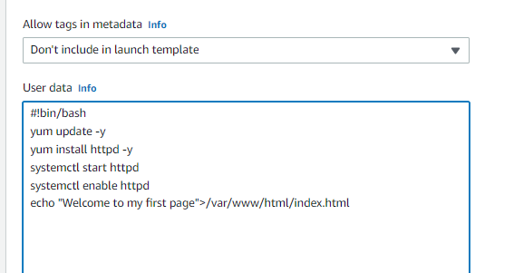

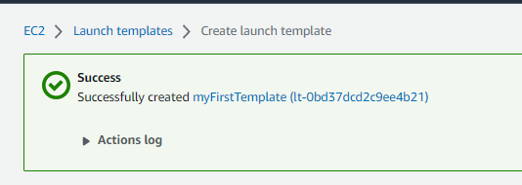

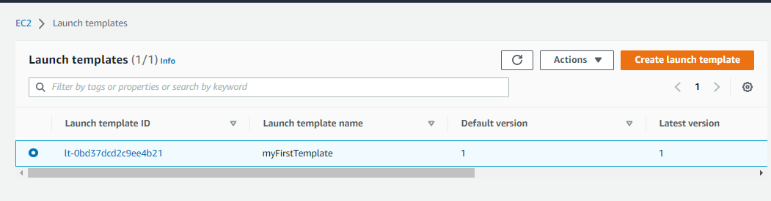

# CREATE AUTO SCALING GROUP

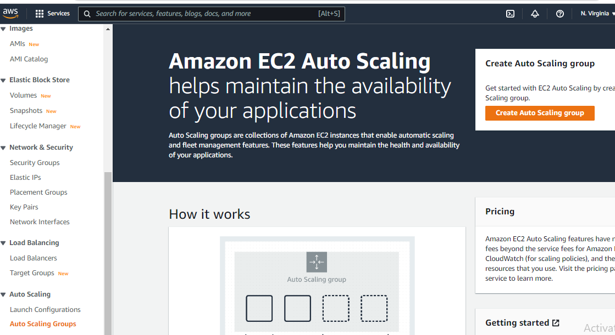

## Attach Template

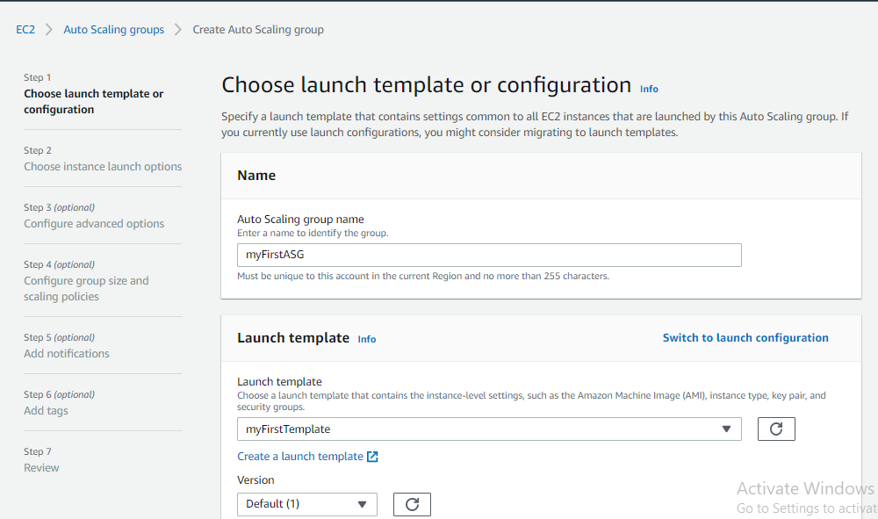

Click next

## Define Network –VPC, Availability Zones and subnet

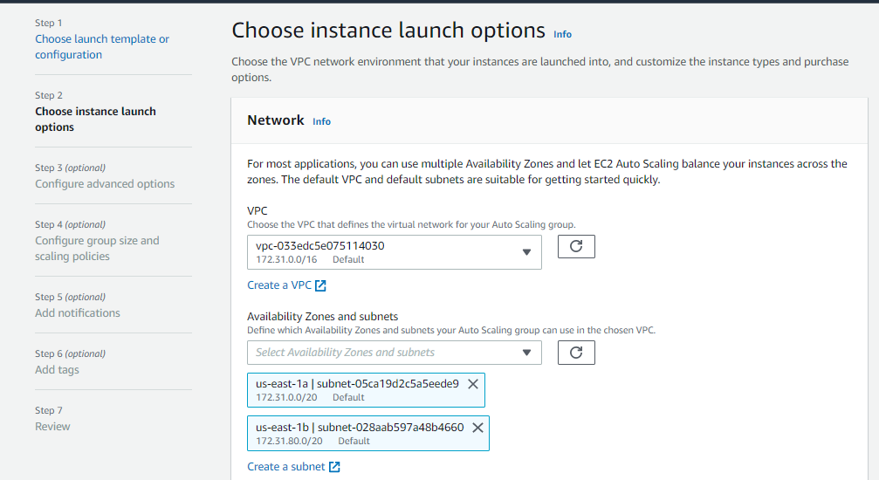

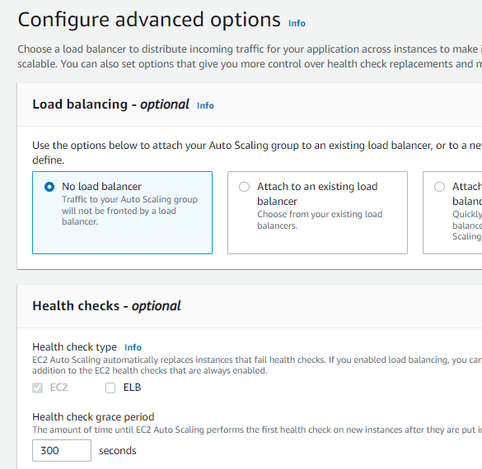

## Configure group size and scaling policies

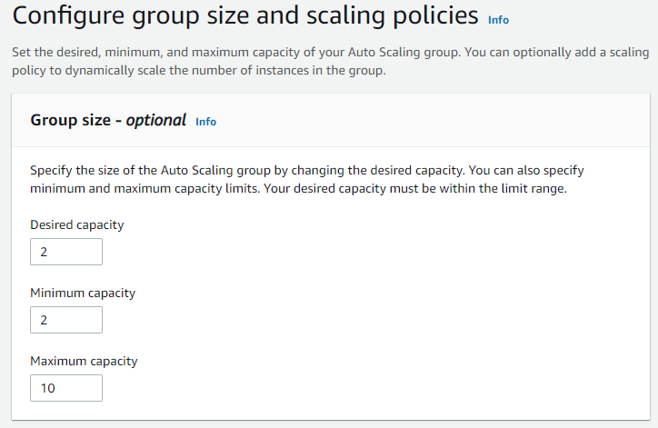

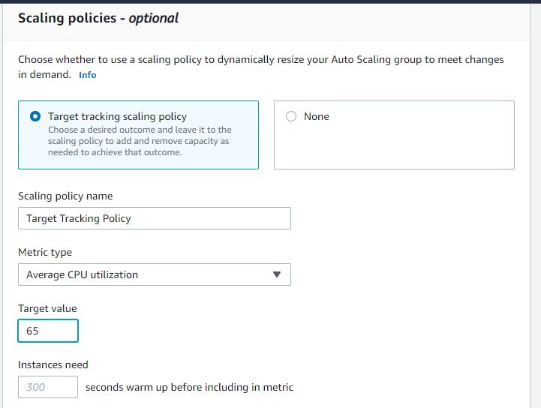

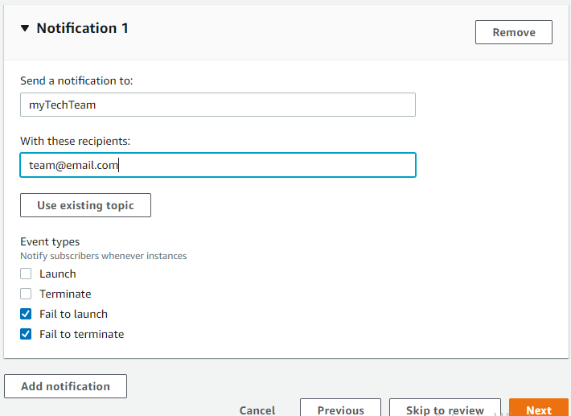

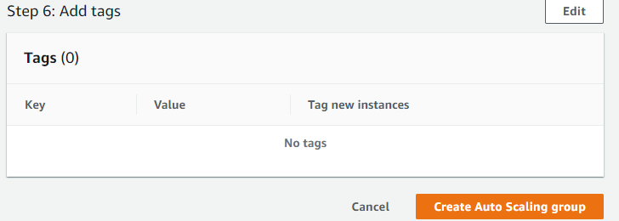

## Check Activity

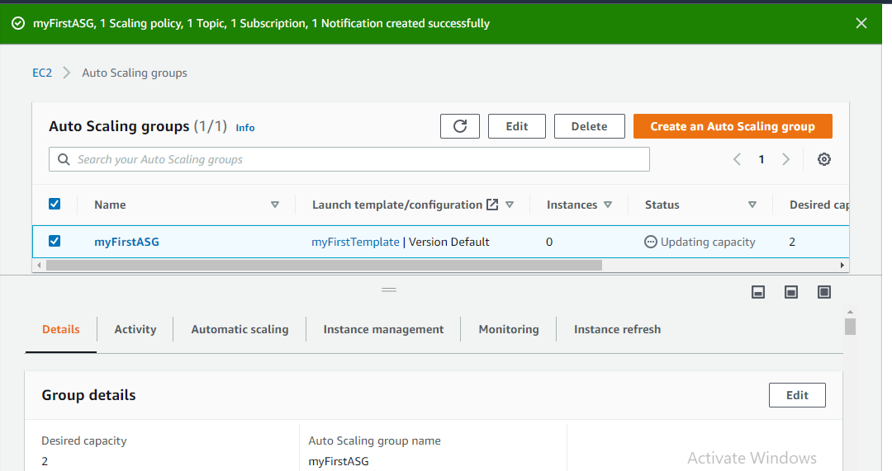

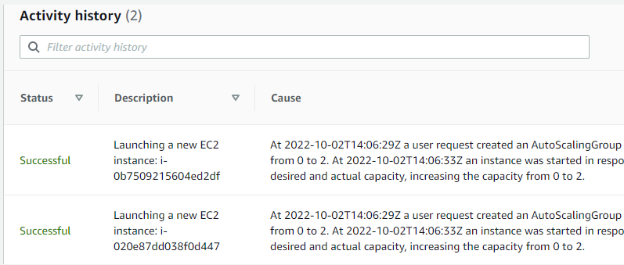

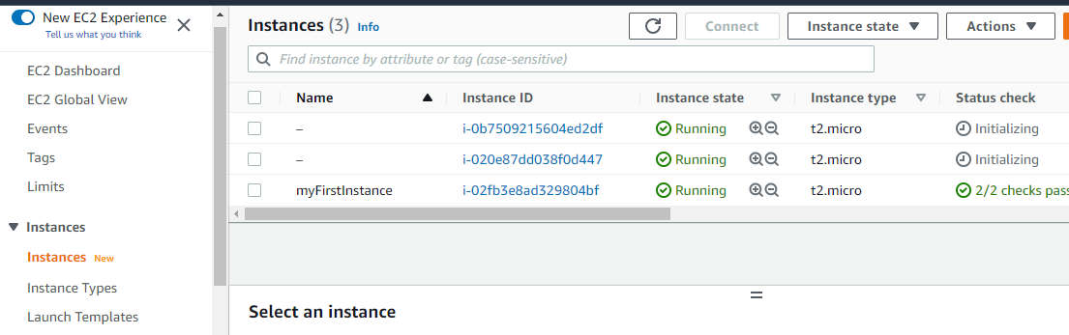

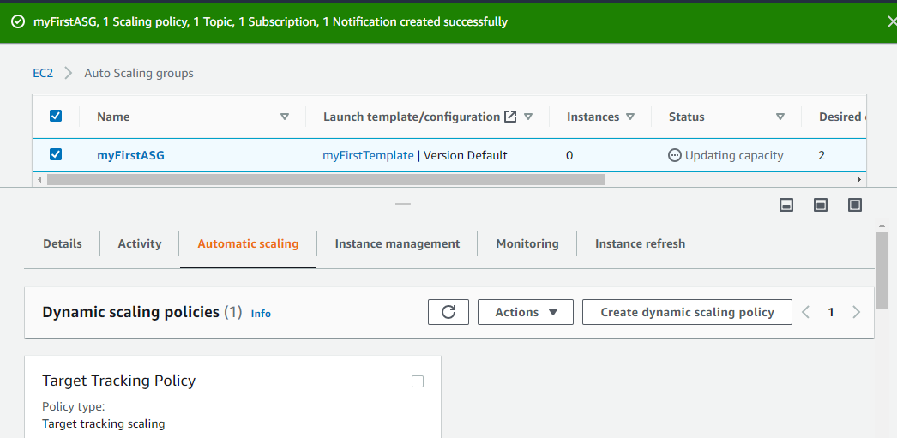

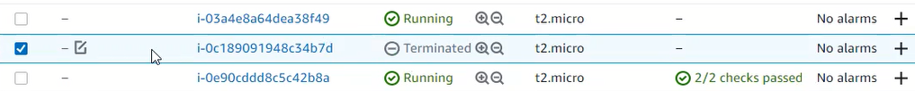

# CREATING TARGET GROUP

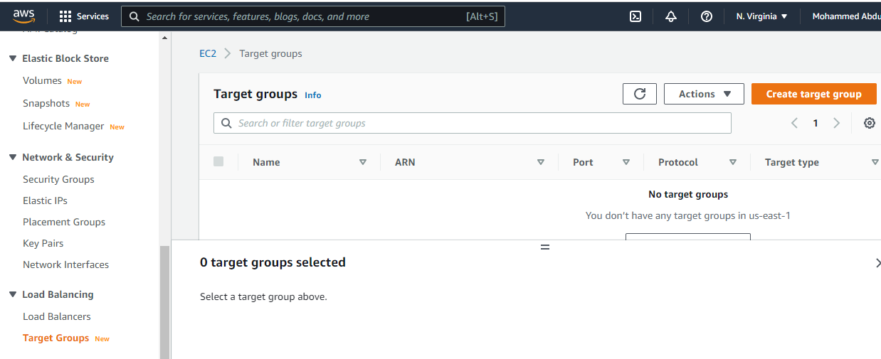

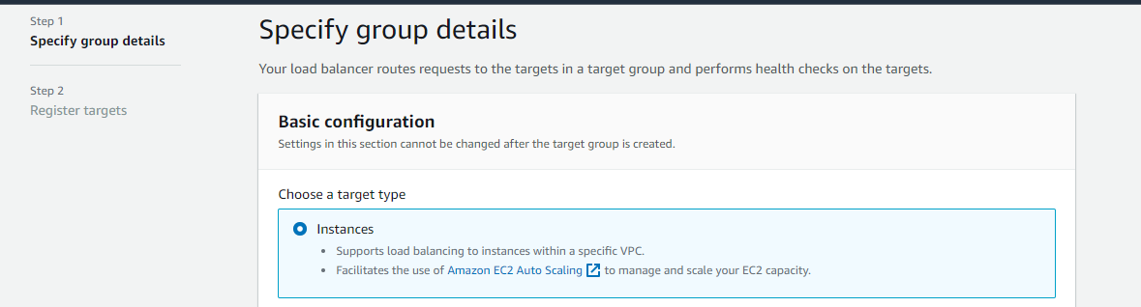

## Name and protocol

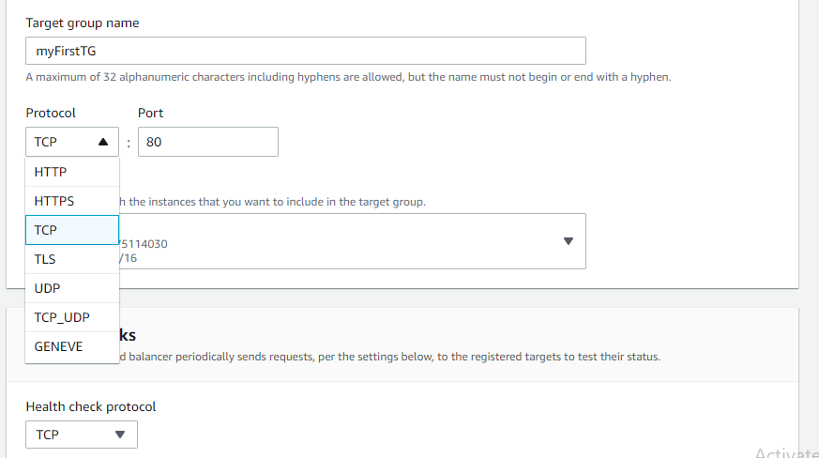

## Register targets and include as pending below

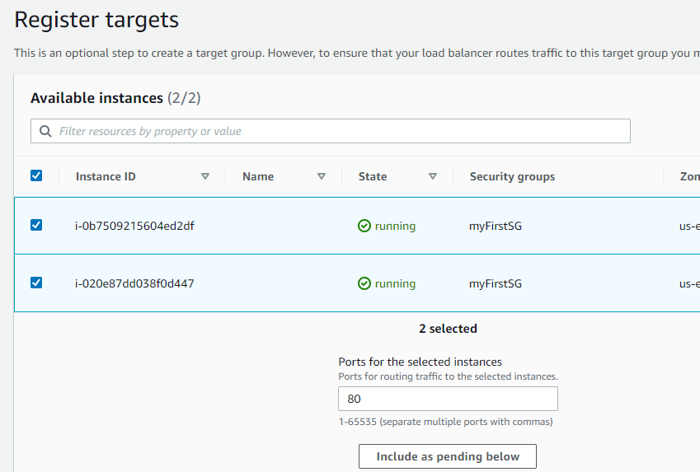

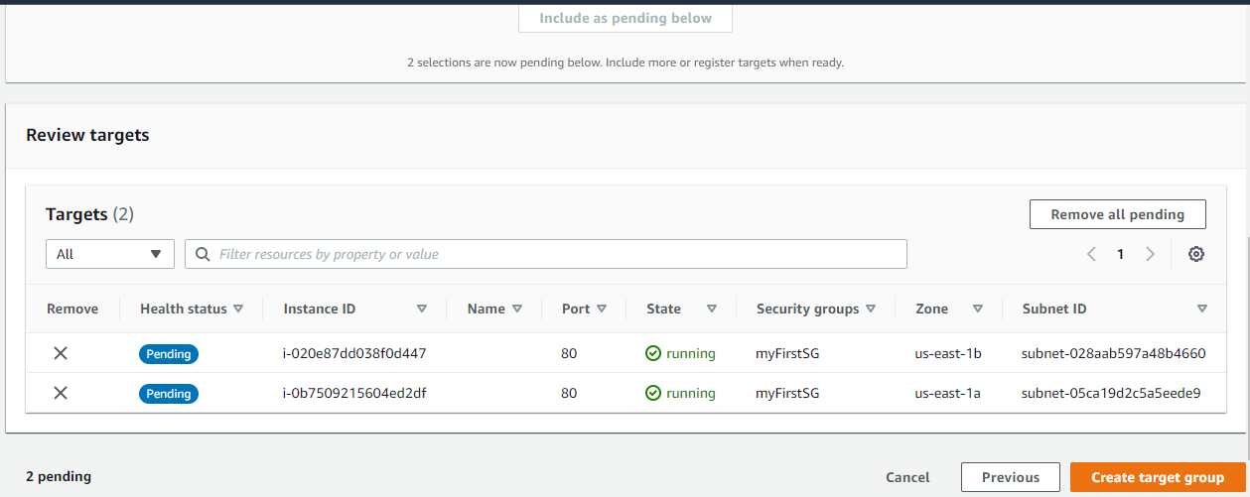

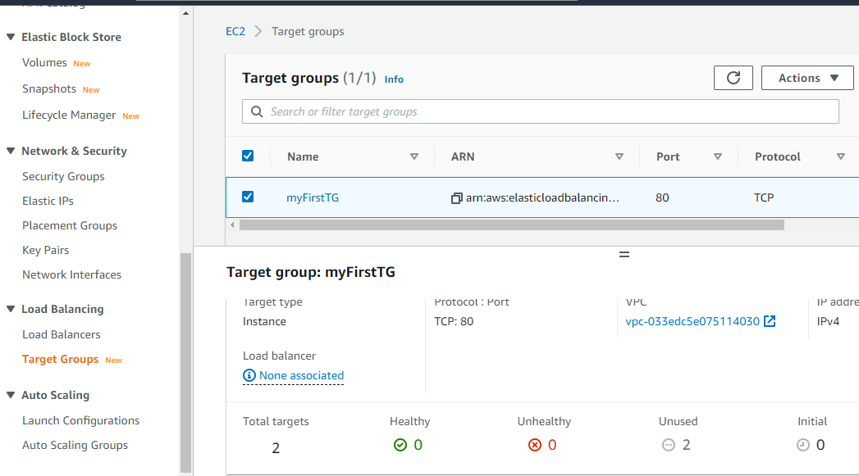

# CREATE LOAD BALANCER

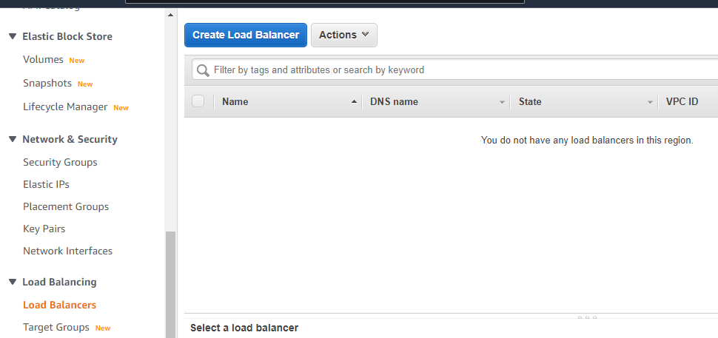

## Types of Load balancer

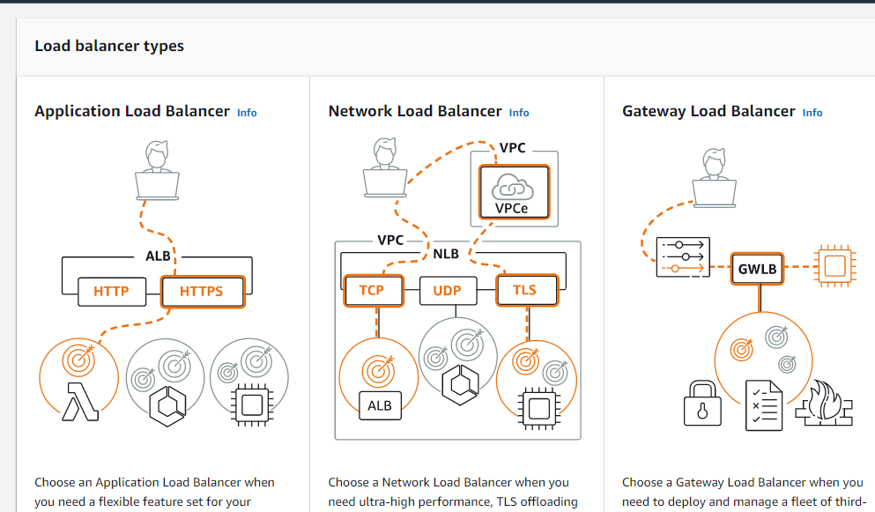

## Type selection

Select NLB

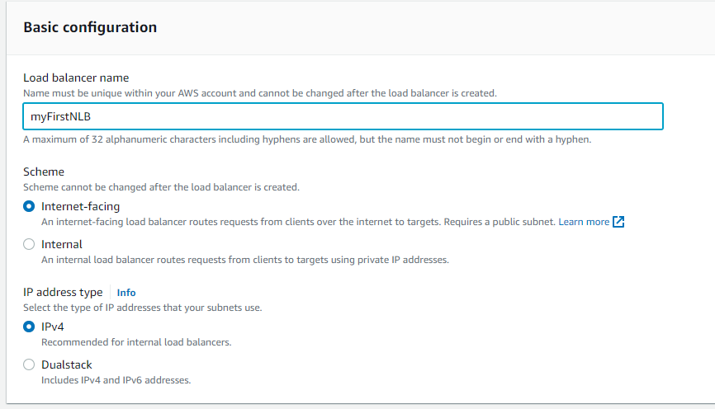

## Network Mapping – Select subnets

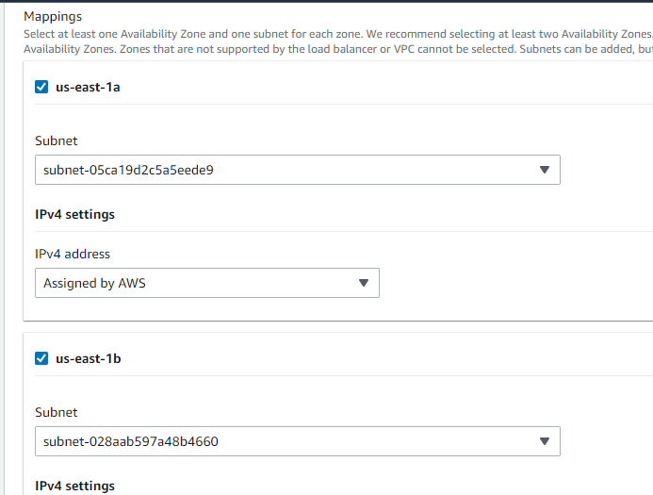

## Attach Target group to Listener

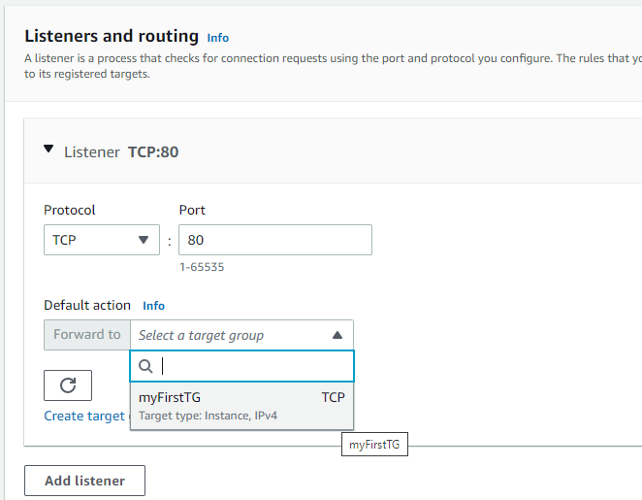

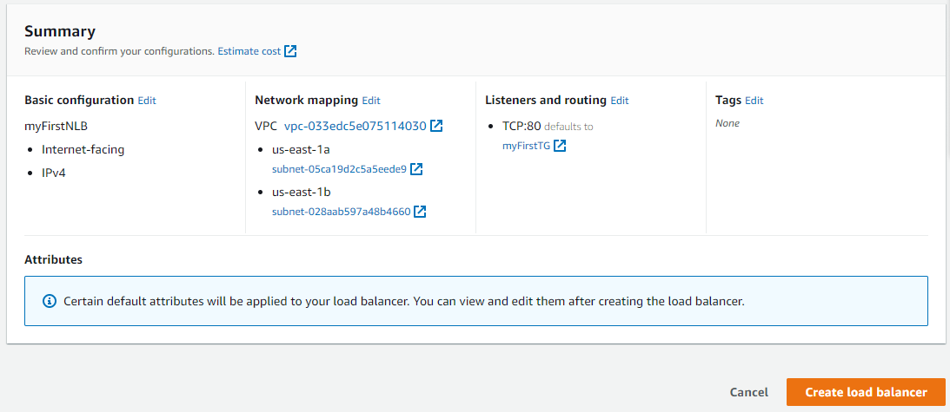

## DNS generation and Test

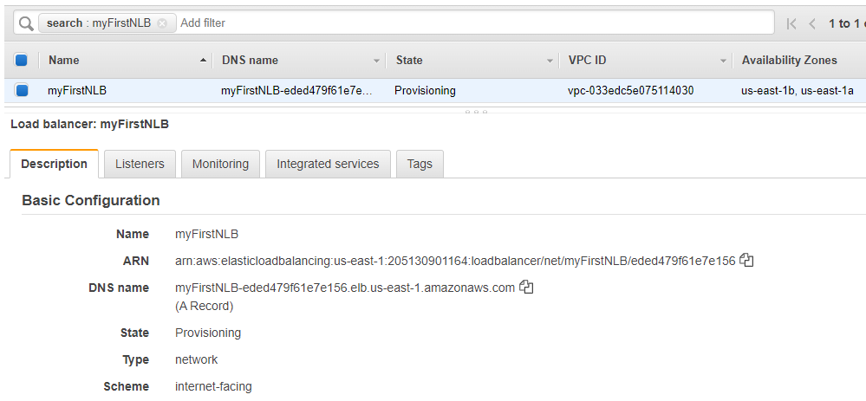

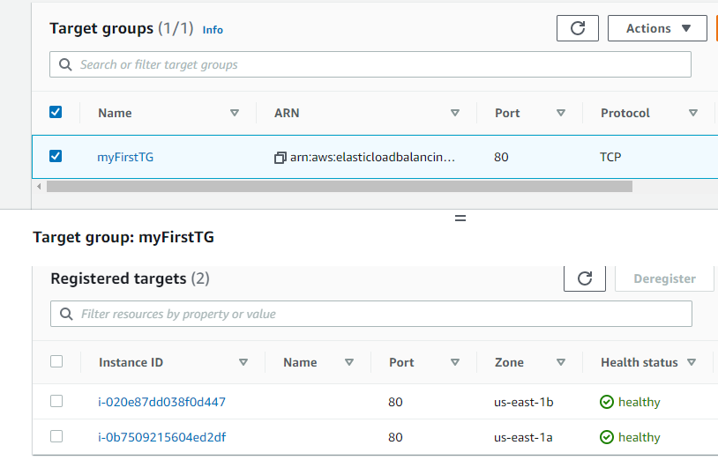

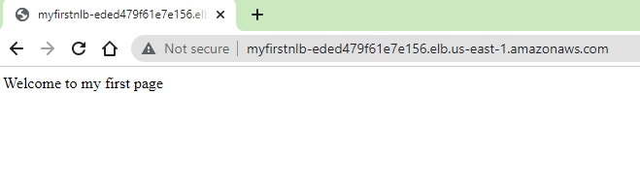

## Enabling Cross-Zone load balancing

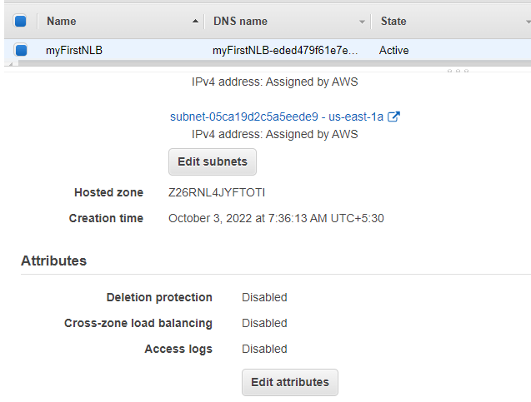

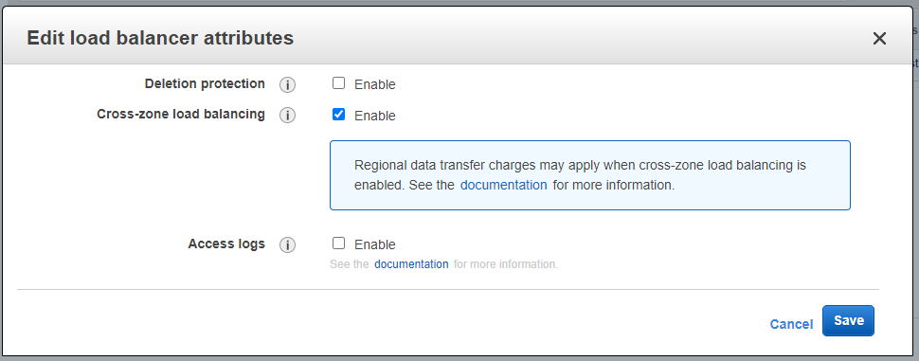

## Attach Target group to Auto Scaling group

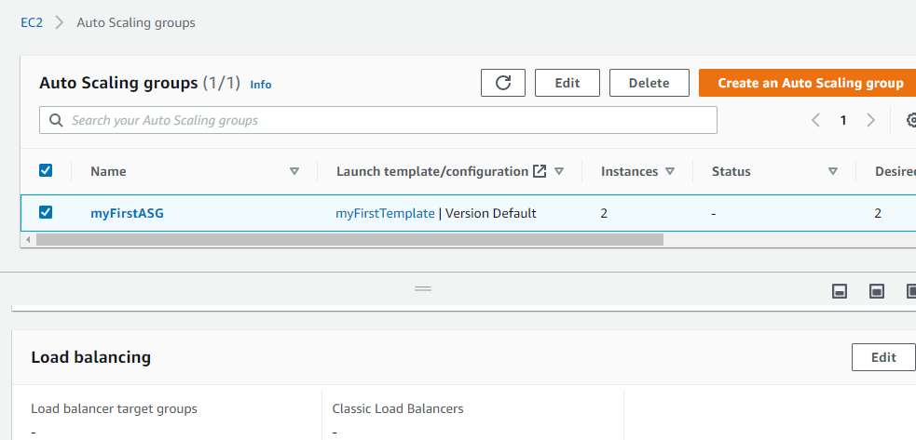

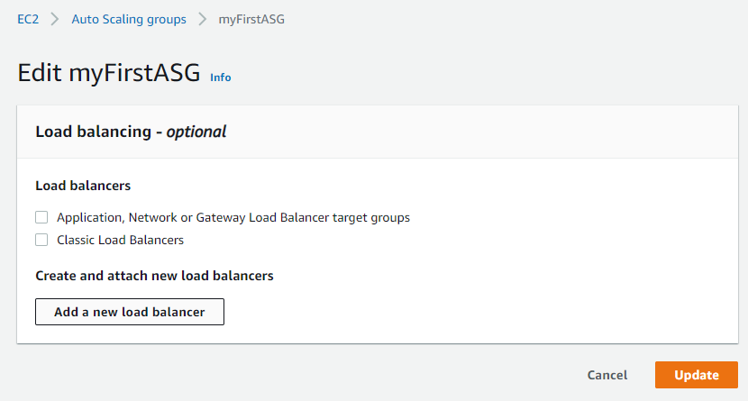

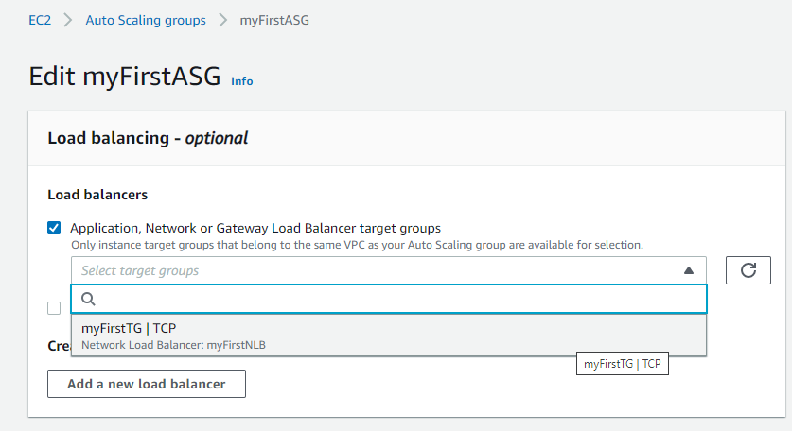

Click Update button

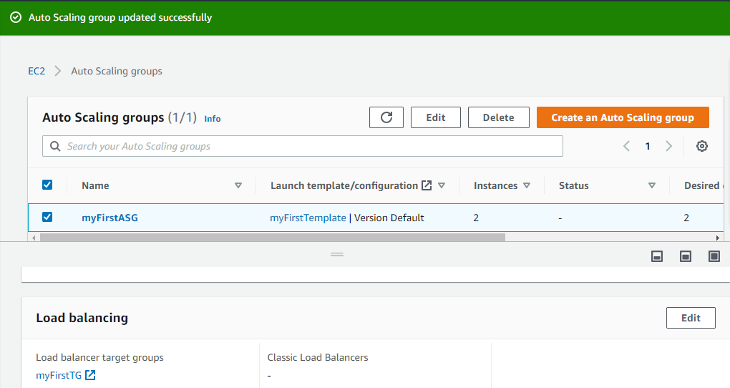

# LIFECYCLE HOOK

* Allows you to pause instances and perform custom actions when a scale-in or scale-out activity happens.
* When configured, the instance in put into a wait state until you continue, or the timeout period ends.

Workflow of Auto scaling **without Lifecycle Hook**.

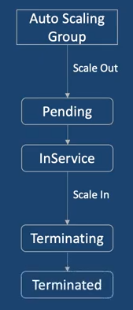

Workflow of Auto scaling **with Lifecycle Hook**.

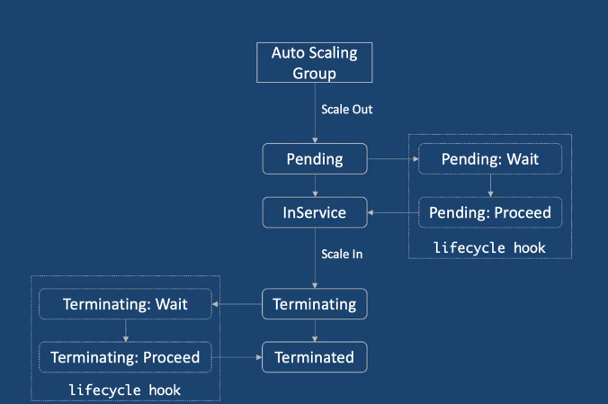

|  |
| --- |
| You can perform custom tasks like, installing software, updating packages, etc. before proceed. |

|  |
| --- |
| You can perform custom tasks like, installing software, updating packages, etc. |

|  |
| --- |
| You can perform custom actions like, backing up the logs before proceed. |

**Use Cases**

* Install a custom software at instance launch.
* Export logs before instance termination.
* Invoke a Lambda function when a lifecycle action occurs.
* Send a notification when an instance launches or terminates.
* **Run a custom script at instance launch**.

|  |
| --- |
| #!bin/bash  yum update –y  yum install httpd –y  systemctl start httpd  systemctl enable httpd  echo “welcome to my first web page”>/var/www/html/index.html |

*Note: httpd (apache)*

**Creating Lifecycle Hook..**

Click **Auto Scaling Group** 🡪 **Instance Management** 🡪 **Create Lifecycle Hook**

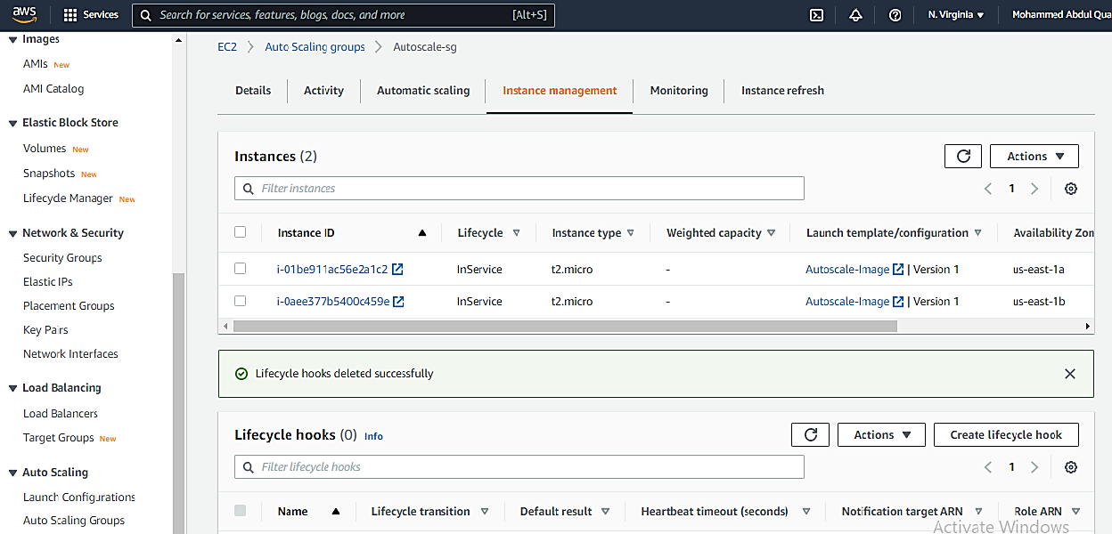

**3**

**2**

**1**

1. Give the Lifecycle Hook name as per the script *myFirstHoot* and click **Create**.

Keep other information unchanged. Default Heartbeat Timeout is 3600 seconds (1 Hour)

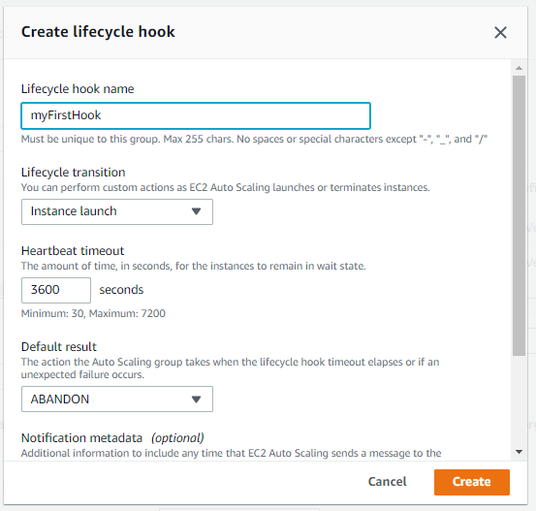

It will wait for 3600 seconds (1 hour) till the following installations performed.

|  |
| --- |
| #!bin/bash  yum install httpd -y && \  service httpd start -y && \  Stopped an Auto Scaling instance. |
| A new instance started spinning. |
| Updated the Heartbeat time out to 30 seconds  The Activity History shows |
| After series of failures. Changing the Heartbeat time out to 3600 seconds  The Activity History shows |
|  |
|  |

# WARM POOLS

AWS Auto Scaling provides scale-out and scale-in resources depending on the instance needs. For example, if a running instance stopped or terminated the Autoscale will launch a new instance replacing the failed instance. This launch takes time as the installation of the software/patches or dependencies prior to the launch must be accomplished. During this certain amount of time the services to the customer hinder. Hence *Unavailability* of the resource arises which is not acceptable.

Solution to the above problem is Warm Pools. “It is a pool of pre-initialized EC2 instances that sits alongside the Auto Scaling Group”. When the application needs to scale-out, warm pool makes sure that it meets its desired capacity by quick start known as warm start.

|  |
| --- |
| **Warm pool size = Auto Scaling group’s max capacity – Desired capacity** |

Click on create warm pool. You can keep one or more instances in the pool.

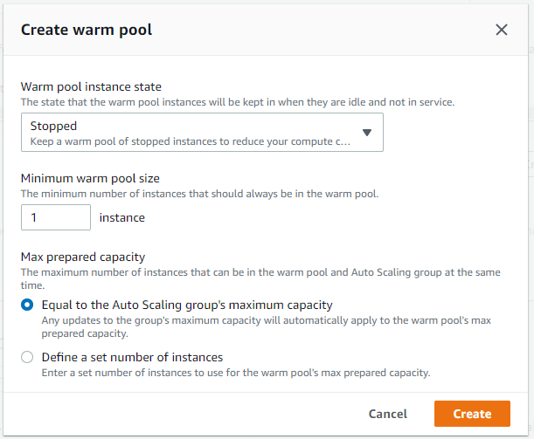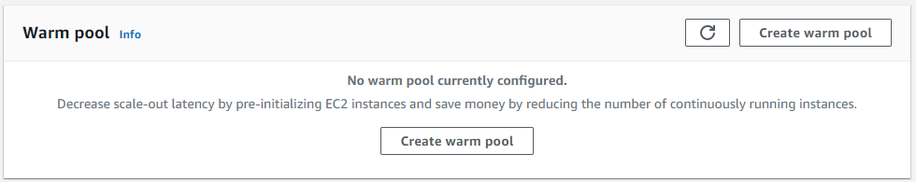

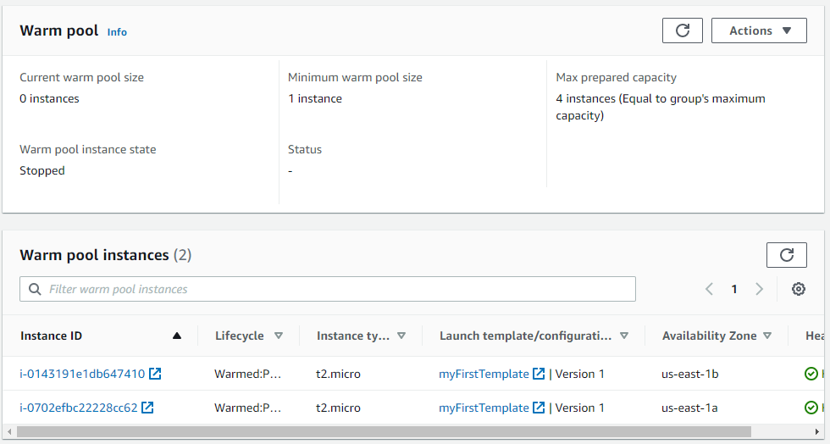

Before Warm Pools

